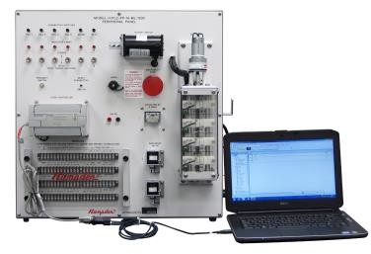
Offered by
Institute of Energy Technology
CUET
REGISTRATION FORM

Training Course
From July 1July 18,2019*
Last date of registration: July 15, 2019*

For information, visit https://www.cuet.ac.bd/institute/iet

Register for (Tick):
Training Course on PLC

Advance Course on Industrial
Automation and PLC

Passport
Photo

Full Name: ………………………………………………………………………………………………………

Current Status/Position: …………………………………...........................................................

NID No………….………………………………………. Major/Department: ………………………………………................. Phone: …………………………………………………. Student ID (CUET students)…………………………………………. Address: …………………………………………………………………………………………………………………………………………
Details of the Last Degree Achieved:

Degree Name: ………………………………………………………………………………………………………………………………….. Institution: ……………………………………………………………………………………………………………………………………… City: ………………………………………………………………. Email: ….………………………………………………………………..
General Eligibility before apply (a) for training course for PLC, (b) for advanced course on Ind. Auto. And PLC:

(a) Knowledge on Basic Electrical, Basic Mechanical drawing, Basic Computer operations

(b) Basic knowledge on PLC, Ladder diagram, Electro-mechanical systems

Please attach the following documents with the registration form before submitting:

¬ Passport sized photo.
¬ Certificates of the degrees achieved so far.
¬ Receipt of the payment** of registration fee from Sonali Bank, CUET Branch, Chittagong, Bangladesh.

Terms and condition:
* Dates can be varied with IET official decision.
** All the payments are not refundable.
*** Prepare all of the above-mentioned documents with the application form and submit to the IET office within the mentioned deadline.

I hereby agree to register in the above mentioned short course.

Applicant sign and date ----------------------------

